1. Backup user’s files
   1. Log into machine using your Zero token.

Open file explorer and navigate to This PC > C:\ drive > Users > User’s username



* 1. Select Desktop, Documents, Downloads and favorites and copy them to their personal drive. You can also copy their files to their One Drive.

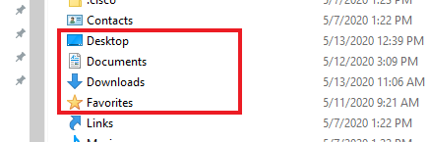

* 1. Next, you’ll want to copy their chrome book marks as well. Navigate to This PC > C drive> Users > User > AppData > Roaming > Chrome. Copy that folder to either their personal drive or their One Drive



* 1. Close all windows and log out of machine

1. Remove machine from CM
   1. Log into dBat with your Zero Token

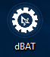

* 1. Select the CM tab on towards the top of the page

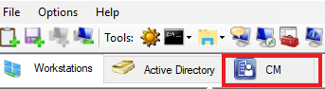

* 1. Click the drop down and select VAPHCSMSP03.VHA.MED.VA.GOV and click connect.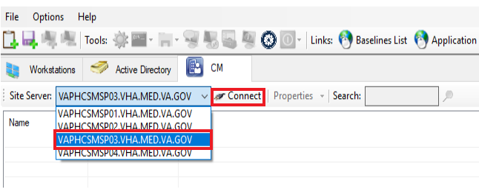
  2. Once connected, search with the computer name. Once its found, right click on the computer name and select Delete

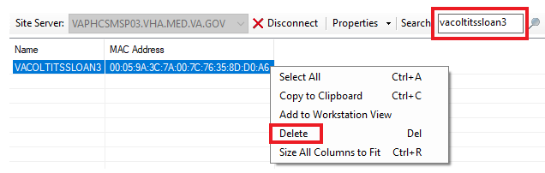

* 1. Once Deleted, close dBat.

1. Moving Machine to Staging
   1. Right click on Active Directory Users and Computer and select run as administrator. Select your Zero account when prompted

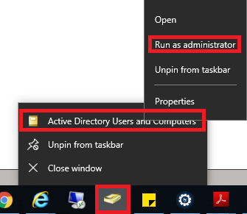

* 1. Once AD is open, select the search icon

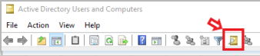

* 1. Once the search box is open, Select the first drop down and select Computers and then select the domain in the second drop down. Once selected, search for the computer

